Austria
The Grand alliance had avowed that Austria was a separate nation that was the first victim of Hitler's aggression. The Allies fear of a supposed "national redoubt” in the Alps at the end of World War Two made the Americans particularly commit to an occupation.

In the immediate aftermath of the war, Austria, like Germany, was divided into four occupation zones and jointly occupied by the United States, Soviet Union, United Kingdom and France. Vienna, like Berlin, was similarly subdivided but the central district was administered jointly by the Allied Control Council.

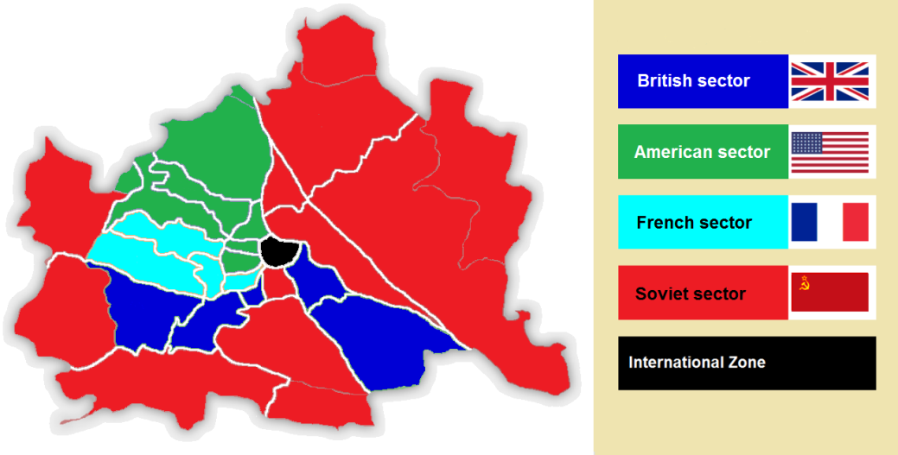

Whereas Germany was divided into East and West Germany in 1949, Austria remained under a largely disjointed occupation of the Western Allies and of the Soviet Union.

Austria had more value as a bargaining chip for the Soviets than as another unstable client state. The continuing talks on Austrian independence stalled in 1948 but progressed to a "near breakthrough" in 1949: the Soviets lifted most of their objections, and the Americans suspected foul play. The Pentagon was convinced that the withdrawal of Western troops would leave the country open to Soviet invasion of the Czechoslovak model.

By negotiating an end to the Austrian occupation, the hope in Moscow was that the Soviets' position on a neutral Germany would gain traction in the FRG.

After Stalin's death in 1953 and the resulting ‘thaw’, or warming of relations known as the ‘Khrushchev Thaw’, the Soviets saw a renegotiation of the occupation as an opportunity to signal a new direction in the Soviet relationship in Europe.

After Austrian promises of perpetual neutrality, Austria was accorded full independence on 15 May 1955 and the last occupation troops left on 25 October that year. On a more practical level, the ending of the occupation finalised what was becoming a costly occupation for the Soviets, and indeed for the West.

A neutral Austria had an additional benefit to the Soviets by creating a gap in NATO's German and Italian front line, which would complicate NATO's existing military plans.

Many in the US State Department saw the Austrian State Treaty as Austria undertaking a voluntary decision to become another Switzerland. The Americans gambled that although neutral, Austria would politically and culturally align itself with the West.

The Soviet's insistence on Austria's military neutrality was a marked change from other Soviet peace treaties. There was little concern of "Finlandisation" in which a peace treaty with the Soviets also carried certain defense obligations that favored the Soviets.

Soviet withdrawal from Austria during 1955 was a sign that communisation was not a policy of the USSR by that time.

